Lagged cross-correlation: USDCAD and EURGBP
Method 12 / daily log returns / K_max=10 / Alpari D1 full available history

Study setup
Logical pair: USDCAD , EURGBP
Broker symbols: USDCAD_i , EURGBP_i
Snapshot: 2026-11-03_majors_alpari_D1
Timeframe: D1
Matched return window: 1999-01-06 to 2026-11-02 (UTC bar dates)
Matched return count n: 7185
Dropped unfinished last bar dated 2026-11-03 UTC after a tick-volume check against the prior complete day.
Lag definition: rho_X->Y(k) = Corr(x_t, y_{t+k}) on matched D1 bars
K_max = 10; headline lag k = 1 (both directions)
Complete matched rows (Excel): USDCAD-EURGBP_Lagged_D1.xlsx
Complete matched rows (HTML table): USDCAD-EURGBP_Lagged_D1_data.html

Method carried forward
Lagged cross-correlation measures Pearson correlation between matched daily log returns of close, ln(close_t / close_t-1), after shifting one series forward by k bars on the matched panel. Quotes are not inverted. rho_{X->Y}(k) = Corr(x_t, y_{t+k}) with n_k = n - k. K_max = 10 is fixed before estimation. The headline is the pre-specified lag k = 1 in both directions. k = 0 is the same-bar side check. The lag inside 1..10 with the largest absolute rho is stored as a descriptive column only; it is not a selected result. This is a linear screen, not proof of forecast edge, economic cause, or a trading signal.

Results (headline k=1)
rho_USDCAD->EURGBP(1): 0.039579 (n=7184)
95% Fisher interval USDCAD->EURGBP: [0.016470, 0.062647]
rho_EURGBP->USDCAD(1): 0.015954 (n=7184)
95% Fisher interval EURGBP->USDCAD: [-0.007173, 0.039065]
Same-bar rho(k=0): -0.014622
Largest |rho| among k=1..10 (descriptive only, not selected): USDCAD->EURGBP k=1 rho=0.039579; EURGBP->USDCAD k=4 rho=-0.035444

CCF table
k | rho_USDCAD_to_EURGBP | n_USDCAD_to_EURGBP | rho_EURGBP_to_USDCAD | n_EURGBP_to_USDCAD
0 | -0.01462189 | 7185 | -0.01462189 | 7185
1 | 0.03957925 | 7184 | 0.01595414 | 7184
2 | 0.01953097 | 7183 | -0.02088007 | 7183
3 | -0.01533671 | 7182 | 0.00891816 | 7182
4 | 0.00226951 | 7181 | -0.03544426 | 7181
5 | -0.00541092 | 7180 | -0.01139751 | 7180
6 | -0.00334355 | 7179 | -0.02408534 | 7179
7 | 0.00582645 | 7178 | -0.02307627 | 7178
8 | 0.01305355 | 7177 | -0.02276572 | 7177
9 | 0.03313344 | 7176 | 0.00141482 | 7176
10 | -0.0014166 | 7175 | -0.00491111 | 7175

Conclusion
At the pre-specified lag k=1 for USDCAD and EURGBP, rho_{USDCAD->EURGBP}(1) = 0.0396 (n=7184) and rho_{EURGBP->USDCAD}(1) = 0.0160 (n=7184). Same-bar rho(k=0) = -0.0146. Largest |rho| among k=1..10 is descriptive only: USDCAD->EURGBP at k=1 (0.0396); EURGBP->USDCAD at k=4 (-0.0354). This is a linear screen, not forecast proof or a trading signal.

Charts
Daily closes

Daily log returns

CCF both directions k=0..10
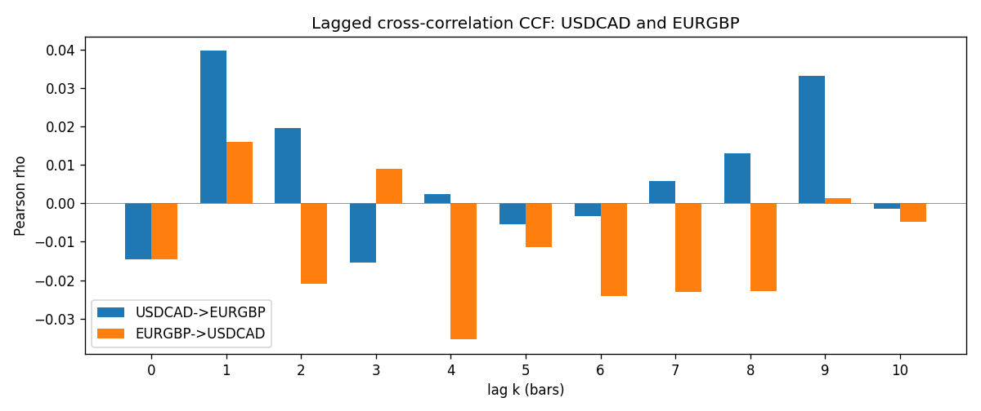

Data report
Every matched row is stored in the sibling Excel workbook named USDCAD-EURGBP_Lagged_D1.xlsx (sheet matched_rows). The CCF sheet holds rho(k) for k=0..10. Embedding all rows as a Word table is impractical; the Word file holds column summaries and the first and last 15 rows.
Columns: time, USDCAD_open, EURGBP_open, USDCAD_high, EURGBP_high, USDCAD_low, EURGBP_low, USDCAD_close, EURGBP_close, USDCAD_tick_volume, EURGBP_tick_volume, USDCAD_spread, EURGBP_spread, USDCAD_real_volume, EURGBP_real_volume, USDCAD_log_return, EURGBP_log_return
Column summaries (matched calculation rows)
column | count | mean | std | min | 25% | 50% | 75% | max
USDCAD_open | 7185 | 1.2666594 | 0.16886861 | 0.9168 | 1.1183 | 1.29841 | 1.37203 | 1.6183
EURGBP_open | 7185 | 0.78693389 | 0.09666561 | 0.5734 | 0.6876 | 0.83387 | 0.86521 | 0.9769
USDCAD_high | 7185 | 1.2715589 | 0.16882635 | 0.9336 | 1.1227 | 1.30381 | 1.3764 | 1.619
EURGBP_high | 7185 | 0.79000929 | 0.09704455 | 0.5789 | 0.6896 | 0.8369 | 0.8681 | 0.9799
USDCAD_low | 7185 | 1.2621046 | 0.16891061 | 0.9056 | 1.11396 | 1.29347 | 1.36776 | 1.6102
EURGBP_low | 7185 | 0.78423344 | 0.09648411 | 0.5682 | 0.6855 | 0.83166 | 0.86287 | 0.9661
USDCAD_close | 7185 | 1.2666836 | 0.16885076 | 0.916 | 1.118 | 1.29833 | 1.3723 | 1.6137
EURGBP_close | 7185 | 0.78697576 | 0.09666885 | 0.5735 | 0.6878 | 0.83391 | 0.86533 | 0.977
USDCAD_tick_volume | 7185 | 81049.359 | 147325.09 | 37 | 5563 | 40946 | 71633 | 1410818
EURGBP_tick_volume | 7185 | 87109.869 | 145486.28 | 154 | 6553 | 44326 | 81375 | 1424684
USDCAD_spread | 7185 | 23.430202 | 18.259258 | 0 | 9 | 17 | 40 | 60
EURGBP_spread | 7185 | 21.335421 | 19.123862 | 0 | 4 | 13 | 40 | 50
USDCAD_real_volume | 7185 | 1.8384377e+10 | 9.670755e+10 | 0 | 0 | 0 | 0 | 2.5751613e+12
EURGBP_real_volume | 7185 | 2.7864528e+10 | 1.3519652e+11 | 0 | 0 | 0 | 0 | 3.5726265e+12
USDCAD_log_return | 7185 | -8.08e-06 | 0.00514591 | -0.03859748 | -0.00283484 | 5.597e-05 | 0.00272835 | 0.03436319
EURGBP_log_return | 7185 | 1.874e-05 | 0.00486681 | -0.03067367 | -0.00262366 | -0.00010035 | 0.00255918 | 0.06075387
First 15 matched rows (selected columns)
time | USDCAD_close | EURGBP_close | USDCAD_log_return | EURGBP_log_return
1999-01-06 | 1.5118 | 0.7019 | -0.0003306769 | -0.013303338
1999-01-07 | 1.5141 | 0.7097 | 0.0015202092 | 0.011051402
1999-01-08 | 1.511 | 0.7062 | -0.0020495197 | -0.004943862
1999-01-11 | 1.5057 | 0.7053 | -0.0035137769 | -0.0012752393
1999-01-12 | 1.5157 | 0.7077 | 0.0066194721 | 0.0033970309
1999-01-13 | 1.5226 | 0.708 | 0.0045420214 | 0.00042381861
1999-01-14 | 1.5332 | 0.7066 | 0.0069376546 | -0.0019793588
1999-01-15 | 1.5245 | 0.7012 | -0.0056905671 | -0.0076715819
1999-01-18 | 1.526 | 0.7017 | 0.00098344542 | 0.00071280921
1999-01-19 | 1.5302 | 0.7007 | 0.002748513 | -0.0014261269
1999-01-20 | 1.5211 | 0.7021 | -0.0059646885 | 0.0019960086
1999-01-21 | 1.5146 | 0.7016 | -0.0042823796 | -0.00071240297
1999-01-22 | 1.5184 | 0.7004 | 0.0025057712 | -0.0017118406
1999-01-25 | 1.5197 | 0.6966 | 0.00085579808 | -0.0054402425
1999-01-26 | 1.52 | 0.6962 | 0.0001973879 | -0.00057438255
Last 15 matched rows (selected columns)
time | USDCAD_close | EURGBP_close | USDCAD_log_return | EURGBP_log_return
2026-10-13 | 1.4214 | 0.84458 | -0.0046395653 | 0.00020130374
2026-10-14 | 1.42356 | 0.84553 | 0.0015184751 | 0.0011241873
2026-10-15 | 1.41843 | 0.84479 | -0.0036101503 | -0.00087557391
2026-10-16 | 1.41357 | 0.84307 | -0.0034322068 | -0.0020380844
2026-10-19 | 1.41091 | 0.84259 | -0.0018835331 | -0.00056950988
2026-10-20 | 1.40569 | 0.83957 | -0.0037066008 | -0.0035906254
2026-10-21 | 1.4045 | 0.83839 | -0.00084691787 | -0.00140647
2026-10-22 | 1.40081 | 0.83682 | -0.0026307268 | -0.0018743924
2026-10-23 | 1.40085 | 0.83751 | 2.85545e-05 | 0.00082421033
2026-10-26 | 1.40093 | 0.83762 | 5.7106554e-05 | 0.00013133309
2026-10-27 | 1.40449 | 0.83595 | 0.0025379458 | -0.0019957343
2026-10-28 | 1.39911 | 0.83651 | -0.0038379274 | 0.00066967224
2026-10-29 | 1.39895 | 0.83553 | -0.00011436495 | -0.0011722209
2026-10-30 | 1.39751 | 0.83351 | -0.0010298736 | -0.0024205543
2026-11-02 | 1.39837 | 0.83426 | 0.00061519094 | 0.00089940465

